Periodontology
Lec.4 Furcation Involvement Dr. Huda Jasim Jebur

The term furcation involvement” refers to invasion of the bifurcation and/or trifurcation of multirooted teeth by periodontal disease. The primary etiological factor for furcation involvement is bacterial plaque which plays an important role in the etiology of gingivitis and destructive periodontal disease & the long – standing inflammation of periodontal tissues.

- Terms frequently used in furcation involvement
Root complex is the portion of a tooth that is located apical to the cemento-enamel junction (CEJ), i.e. the portion that normally is covered with a root cementum.The root complex may be divided into two parts: the root trunk and the root cone.
The root trunk represents the undivided region of the root. The height of the root trunk is defined as the distance between the CEJ and the separation line (furcation) between two root cones (roots). Depending on the position of the separation line, the height of the root trunk may vary from one surface to the next in one given molar or premolar.
The root cone is included in the divided region of the root complex. The root cone (root) may vary in size and position, and may at certain levels be connected to or separated from other root cones.
Two or more root cones make up the furcated region of the root complex.
The furcation is the area located between individual root cones.
The furcation entrance is the transitional area between the undivided and the divided part of the root .
The furcation fornix is the roof of the furcation.
The degree of separation is the angle of separation between two roots (cones).
Divergence is the distance between two roots; this distance normally increases in the apical direction.

- There are some morphological variations that must be considered in the diagnosis and treatment of furcation involved teeth ,These are:
1-Fusions between divergent roots.
Widely separated roots Close to one another Fused roots
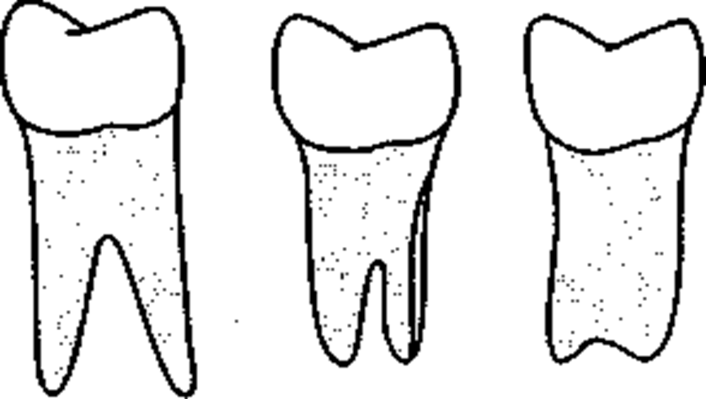
2- Cervical enamel projection or enamel pearl in the furcation areas,They occur approximately in 15 percent of molars. They favor plaque accumulation responsible for furcation invasion & localized severe bone loss around the tooth.
- It was classified by Masters and Hoskins in 1964 as:
Grade I: The enamel projection extends from the cementoenamel junction of the tooth towards the furcation entrance.
Grade II: The enamel projection approaches the entrance to the furcation but does not enter the furcation and hence has no horizontal component.
Grade III: The enamel projection extends horizontally into the furcation.
3-The presence of accessory pulp canals which communicate with the furcation area.
It is believed that once the pulp is infected through the accessory canal, endo-perio communication may result, which in turn can cause either destruction of inter radicular periodontium or interfere with the healing response of either periodontal or endodontic procedures.

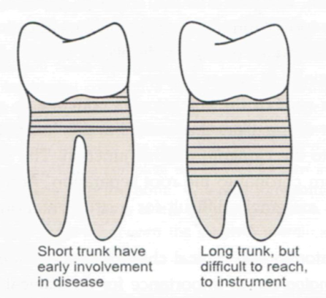
4-The distance between CEJ & furcation area (trunk length).

- Classification Of Furcation Involvement

The classification description of the involved furcation is based on the amount of periodontal tissue destruction that has occurred in the inter‐radicular area, that is the degree of “horizontal root exposure” or attachment loss that exists within the root complex. Hamp et al. (1975) has suggested the following classification of the involved furcation:

• Class I: horizontal loss of periodontal support not exceeding one‐third of the width of the tooth.
• Class II: horizontal loss of periodontal support exceeding one‐third of the width of the tooth, but
not encompassing the total width of the furcation area .
• Class III: horizontal “through‐and‐through” destruction of the periodontal tissues in the furcation area.

- Diagnosis
The examination should comprise both clinical probing and radiographic analysis.

1-Probing
The buccal furcation entrance of the maxillary molars and the buccal and lingual furcation entrances of the mandibular molars are normally accessible for examination using a curved graduated periodontal probe, an explorer or a small curette. The examination of approximal furcations is more difficult, in particular when neighboring teeth are present. Large contact areas between the teeth further impair access to approximal furcation entrances.
In maxillary molars, the mesial furcation entrance is located much closer to the palatal than to the buccal tooth surface. Thus, the mesial furcation should be probed from the palatal aspect of the tooth.
The distal furcation entrance of a maxillary molar is generally located midway between the buccal and palatal surfaces and, as a consequence; this furcation could be probed from either the buccal or the palatal aspect of the tooth.
In maxillary premolars, the root anatomy often varies considerably. The roots may also harbor irregularities such as longitudinal furrows, invaginations or true furcations, which may open at varying distances from the CEJ. Due to the above variations and limited access, the clinical assessment of a furcation involvement in maxillary premolars is often difficult.

2-Radiographs
Radiographs must always be obtained to confirm findings made during probing of a furcation‐involved tooth. The radiographic examination should include both paralleling “periapical” and vertical “bitewing” radiographs. In the radiographs, the location of the interdental bone as well as the bone level within the root complex should be examined.
Situations may occur when findings from clinical probing and from the radiographs are inconsistent. Thus, the localized but extensive attachment loss which may be detected within the root complex of a maxillary molar with the use of a probe will not always appear in the radiograph. This may be due to the superimposition in the radiograph of the palatal root and remaining bone structures.

Differential diagnosis
A lesion in the inter‐radicular space of a multirooted tooth may be associated with problems originating from the root canal or be the result of occlusal overload.
The treatment of a furcation‐involved tooth, therefore, should not be initiated until a proper differential diagnosis of the lesion has been made.

1-Pulpal pathosis
Which may sometimes cause a lesion in the periodontal tissues of the furcation.The radiographic appearance of such a defect may have some features in common with a plaque‐associated furcation lesion. In order to differentiate between the two lesions, the vitality of the affected tooth must always be tested. If the tooth is vital, a plaque‐associated lesion should be suspected. If the tooth is non‐vital, the furcation involvement may have an endodontic origin. In such a case, proper endodontic treatment must always precede periodontal therapy. In fact, endodontic therapy may resolve the inflammatory lesion, soft and hard tissue healing may occur, and the furcation defect will disappear .If signs of healing of a furcation defect fail to appear within 2 months of endodontic treatment, the furcation involvement is probably associated with marginal periodontitis.

2-Trauma from occlusion
Forces elicited by occlusal interferences, for example bruxers and clenchers, may cause inflammation and tissue destruction or adaptation within the inter‐radicular area of a multirooted tooth. In such a tooth, a radiolucency may be seen in the radiograph of the root complex. The tooth may exhibit increased mobility. Probing, however, fails to detect an involvement of the furcation. In this particular situation, occlusal adjustment must always precede periodontal therapy. If the defects seen within the root complex are of “occlusal” origin, the tooth will become stabilized and the defects disappear within weeks following correction of the occlusal overload.

(Check PowerPoint )

Perhaps the simple things are the most distinctive things, but .. not every eye sees
Rumi

